Workflow of each role and step showing how the system works

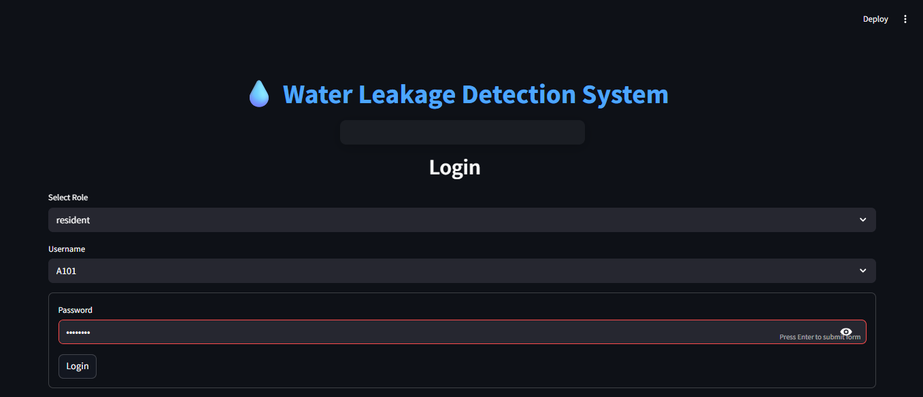
Fig-1: Login credentials page

Login page with different user roles along with their id and password to be entered to login.

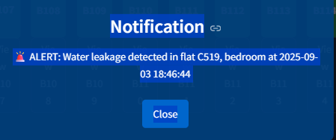
Fig-2: Pop-up Notification showing water leakage detected

Web application gives pop-up notification to the all the users (residents, maintenance teams) when the sensors detect leak in any of the flats along with flat no, room, date and time.

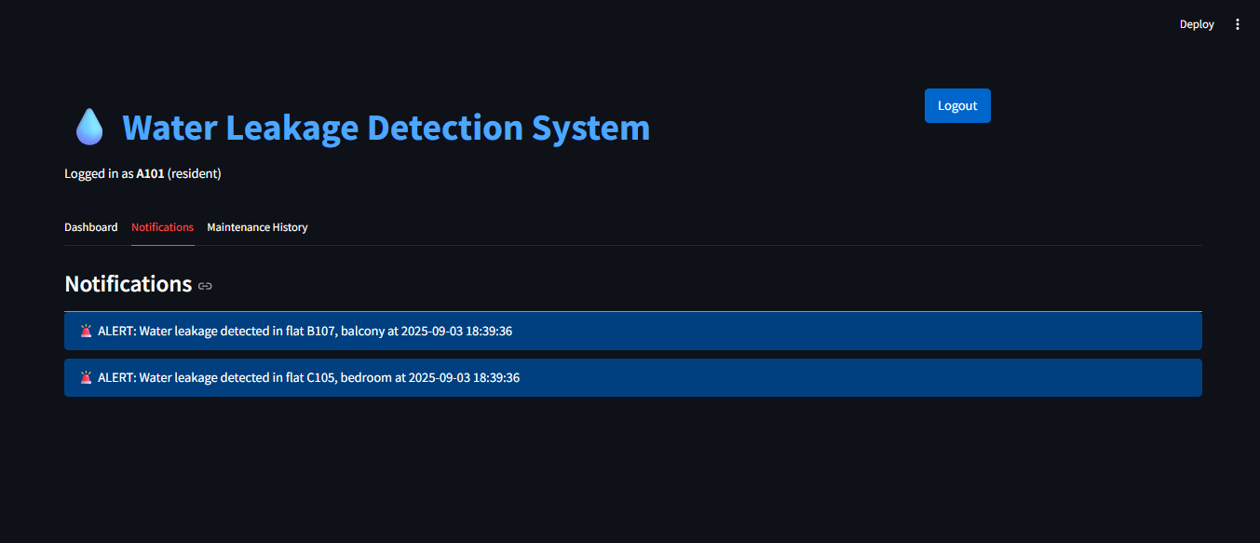
Fig-3: Notification history for a resident

If at all any user misses the pop-up notification, it can be seen inside the notification history.

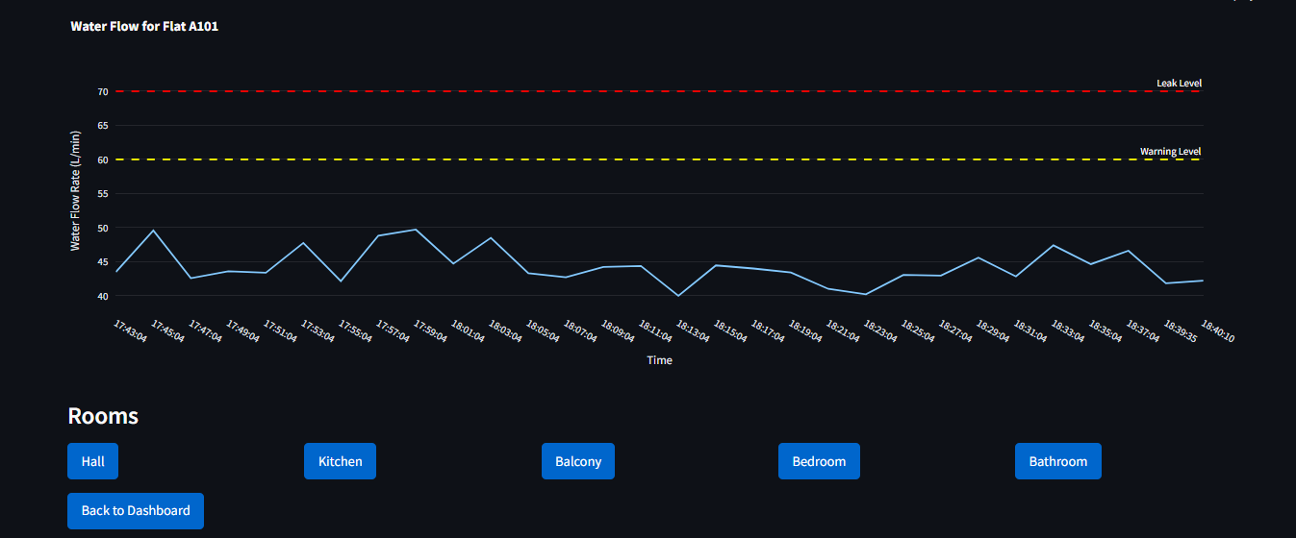
Fig-4: Water level graph of particular resident for each room

Every resident can see his/her flat’s water flow level of every room and it also helps not only when there is a leakage but also when resident faces water flow issues like low water flow through taps etc.
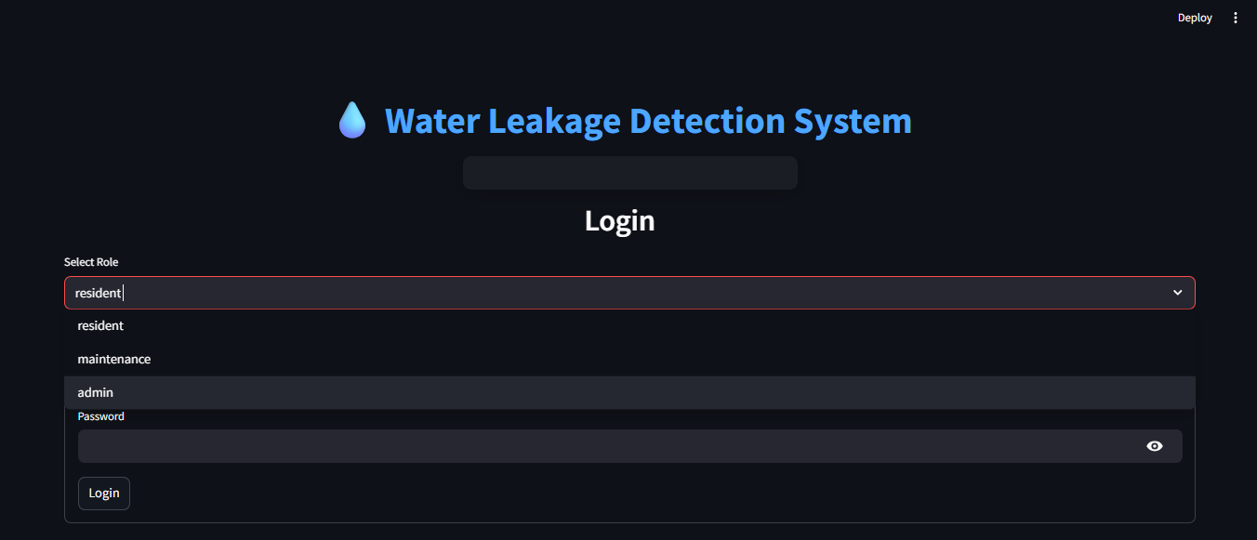
Fig-5: Login page with different user roles
Login page showing all the user roles i.e. Resident, Maintenance team, Admin.

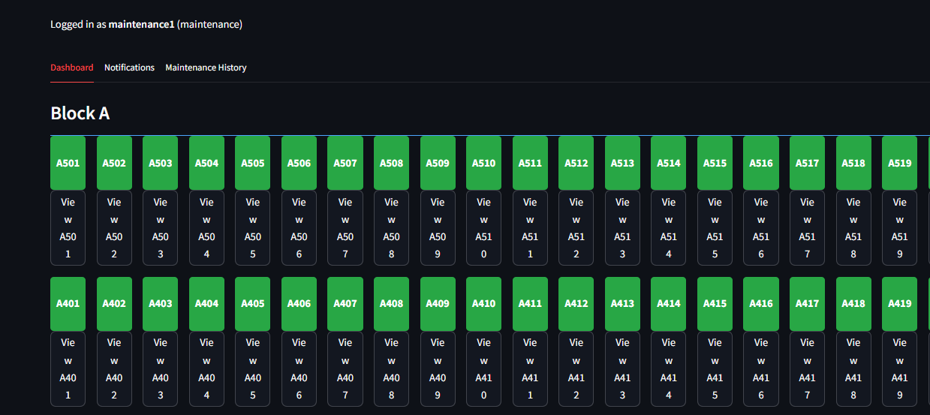
Fig-6: Maintenance team dashboard showing all flats

As maintenance team should look after all the flats in the society, they have the access of every flat’s water flow level with all rooms so that they can have knowledge on all flats about the leaks as well as about the low water flow through taps.

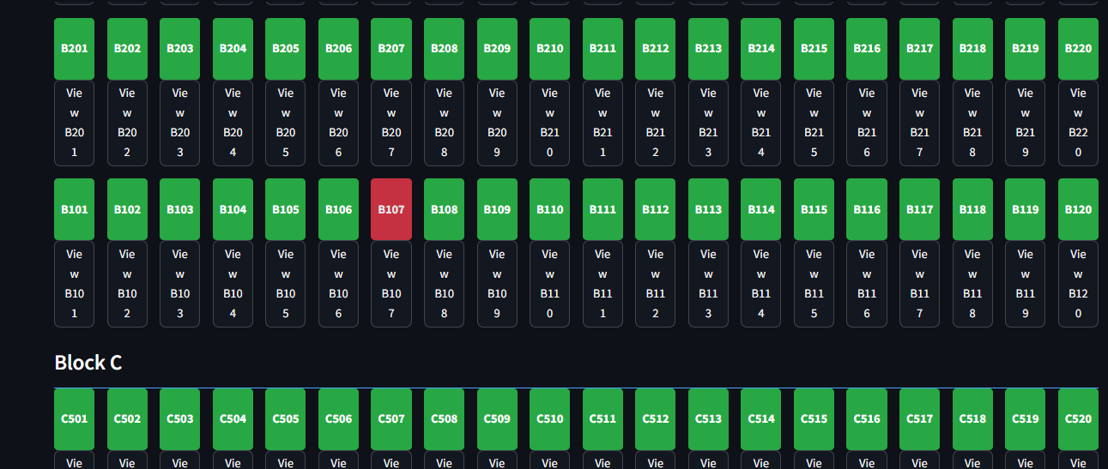
Fig-7: Green => No leakage Yellow => Under Maintenance Red => Leakage detected

Dashboard of maintenance team showing grid like structure of all flats with color indicators,
So that if there’s any leak detected then they get to know which series water services must be paused till the problem is cleared.

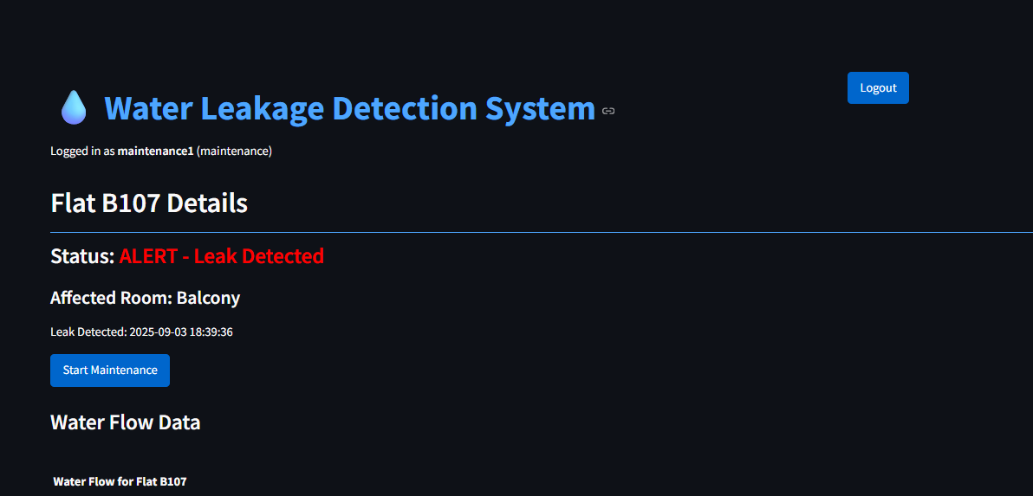
Fig-8: Showing status of particular flat
When a leak is detected in a flat then the resident and maintenance team can see the status along with the affected room, date and time with live water leak level graphs and maintenance start option (only for maintenance team).

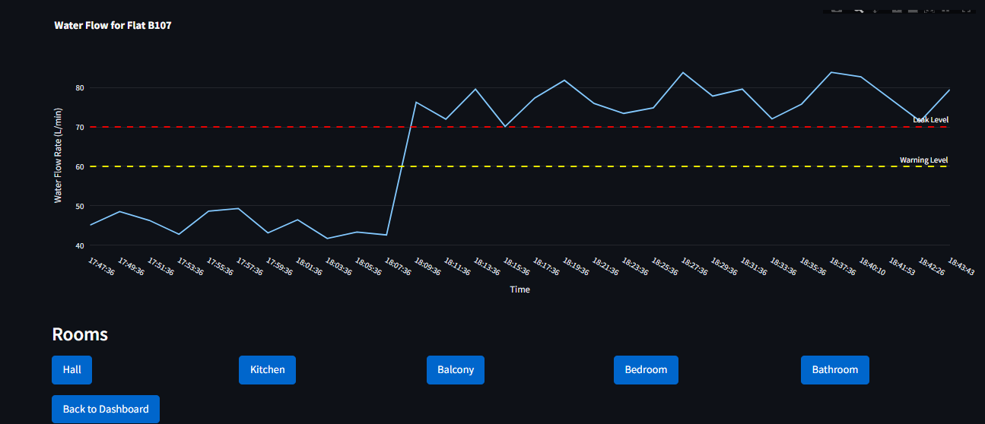
Fig-9: Water Leakage graph showing level w.r.t. time in the flat

The graph shows the water leak level of the flat in the room which indicates warning level and leak level.
If the graph rises high then the leak is more and it should be resolved at the earliest and, if it’s near warning level then the leak is less.

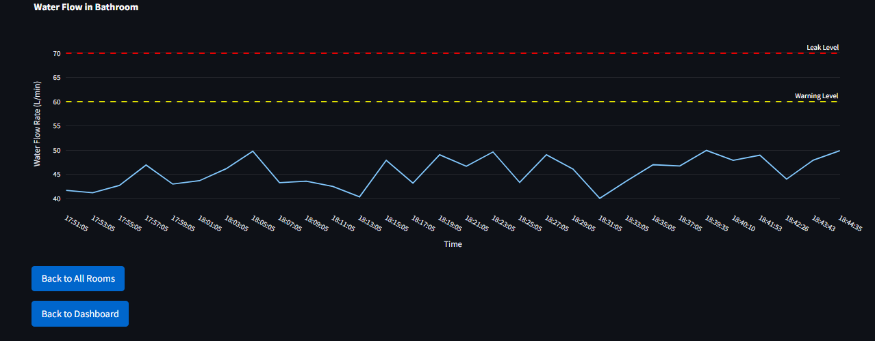
Fig-10: Graph of other room in the same flat with no water leakage

Graph of other room in the leak detected flat which shows its water flow levels which may be helpful for reference at junctions or joints.
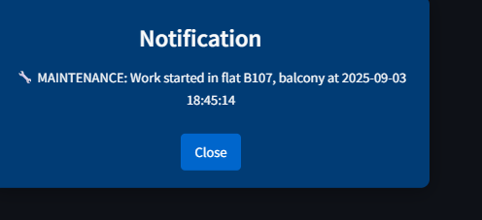
Fig-11: Notification pop-up showing maintenance work started
As soon as maintenance team notices the leak, they arrange the plumber and then pause the water services to that series of flats to prevent leak and also internal property damage which may be caused because of water. Then they use the “Start Maintenance” option which sends notification to all residents that shows plumbing work has been started with flat no, room, date and time.

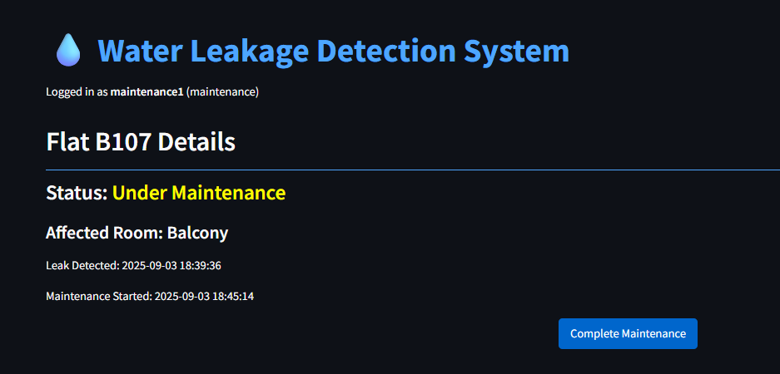
Fig-12: Under Maintenance status
Under maintenance status is shown to maintenance and resident of the flat till the plumbing work is completed and the “complete maintenance” option is given only to maintenance team so that they can use that option after completion of the work.

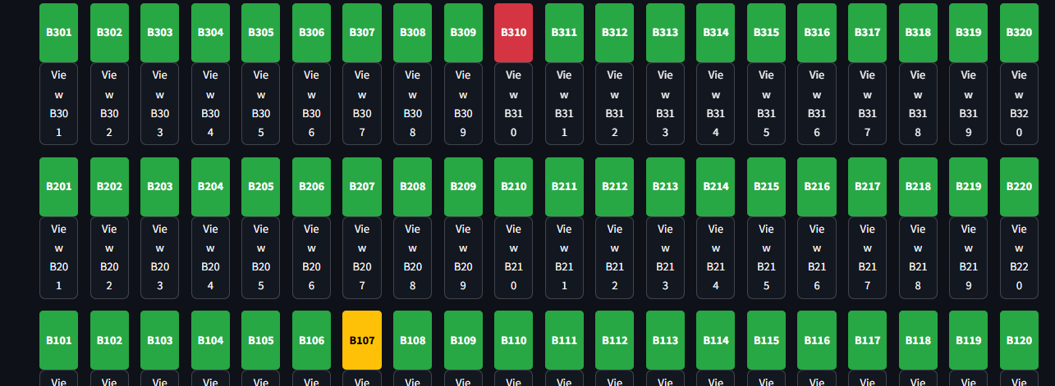
Fig-13: Dashboard showing flats with
Green => No leakage Yellow => Under Maintenance Red => Leakage detected

Dashboard of maintenance team indicating yellow color as maintenance work in progress and red color as water leak detected status.

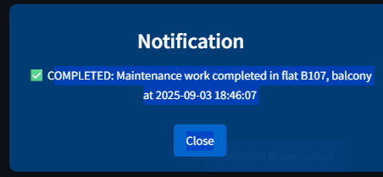
Fig-14: Notification pop-up after completion of maintenance work

Pop-up notification is given to all residents once the maintenance work is completed and the “complete maintenance” option is used by the team stating that residents of that series can resume the water services.

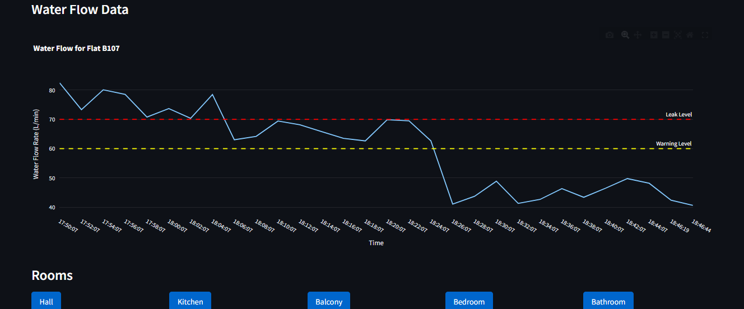
Fig-15: Water flow graph after completion of maintenance work in the flat
Water flow graph showing the levels before, in-progress and after the completion of the work. Decrease in graph level indicates that leak is decreased and stopped.
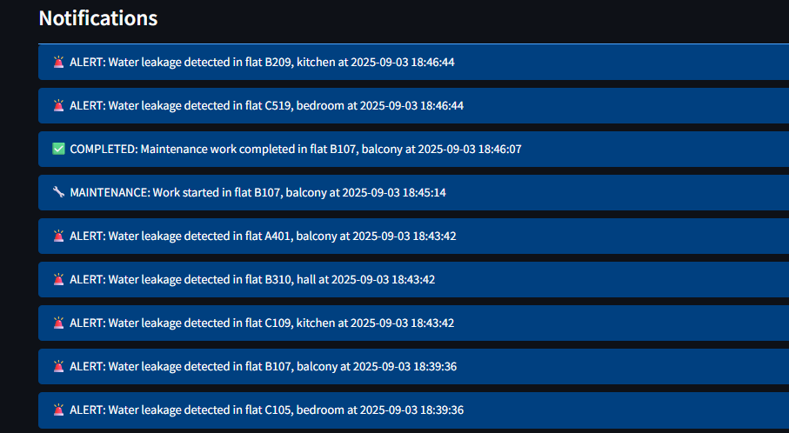
Fig-16: List of notifications in the system for every step

For any further reference or missed notifications, users can access the notification history showing notification of each step.

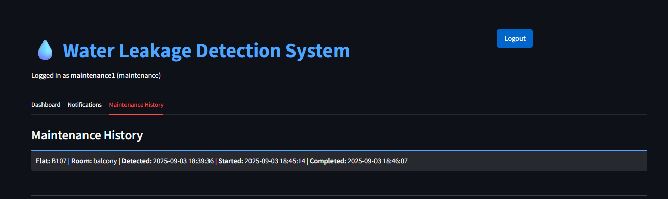
Fig-17: Maintenance history for the particular flat resident and
for the maintenance team for future reference

Maintenance history of the flat can be only accessed by flat resident and maintenance team for future purposes so that if any leaks happen in the particular area, then they can have previous knowledge of that leakage region like when and where it has occurred.

Use of system:
The system also helps when the resident is out of station and then if there’s a leak detected then the maintenance team along with their neighbors/relatives with whom the keys are there gets the notification and can get the work done.
This system also helps in detecting even minor water leaks that are invisible before they get major and damage the property of the resident. This system also detects internal water leakage that is caused by small drips of water and causes property damage

